In Person Event Registration Policy and Procedure v.2020-08-03

Event Registration Goals
- Pre-screening of all attendees (including staff and volunteers) before in person event
- Issuing of tickets to keep events at or below maximum capacity for attendance
- Keep record of contact information for all attendees for contact tracing if a positive COVID-19 case occurs

Protocol
- Every in person event will designate a Secretary, who will record the Event Registration and prepare a list of attendees and their corresponding ticket for the Head Usher at the event. Set up a new Google Credential for the Secretary to be determined by the Ministry Team.

- 7 days before the event (Monday for the following Sunday), the Secretary will publish an on line standardized Event Registration Form from the copy below through “Make a copy” and paste it into the new Google Credential of the Secretary to be determined by the Ministry Team (see Figure 1.):
https://docs.google.com/forms/d/1KZHHjTxxdx5QTheVT0_jFEykq93I4NCUr9gUa1P4kPA/edit (Google Credential for standardized form is jaffrayevents@gmail.com “99Tjcac50”)
Figure 1. Settings
  - Each event must customize the “Title” of the event, including the name, address, date and time, and contact information of that event to be determined by the Ministry Team. (see Figure 2.)
Figure 2. Title
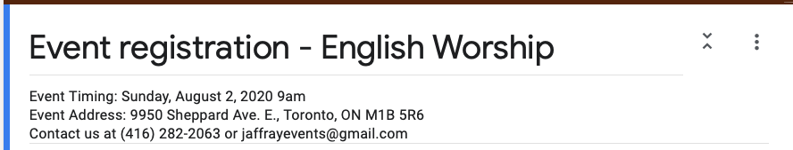
  - Each Ministry Team must establish a process to reach those who do not have internet/email service for Event Registration (e.g. someone to phone potential attendee to complete the on line Event Registration for that person).

- In your customized Event Registration Form, Under “Responses” tab, select the “…” tab on the far right to bring out the Options Menu (see Figure 3.)
Figure 3. Options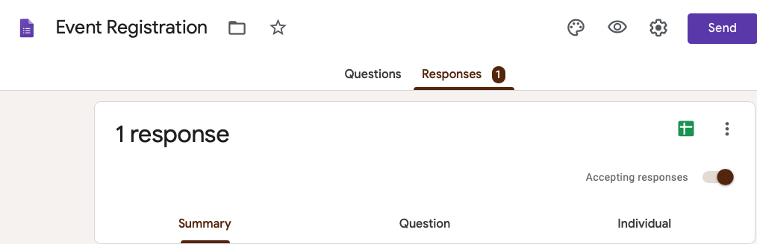

- Select “Get email notifications for new responses” and each time a registration is completed, the Google Credential where you have placed the form will receive an email.
Figure 4. Email Notification

- Notify Deacon Stanley Pak stanley.cy.pak@gmail.com , the Webmaster, or your respective Ministry Team webmaster to provide a link to your event registration on the www.tjcac.org website.

- When you receive email notification of the registration, review the details of the registration (select “Response X”) which will appear in a web page: (see Figure 5.)

Figure 5. Email notification 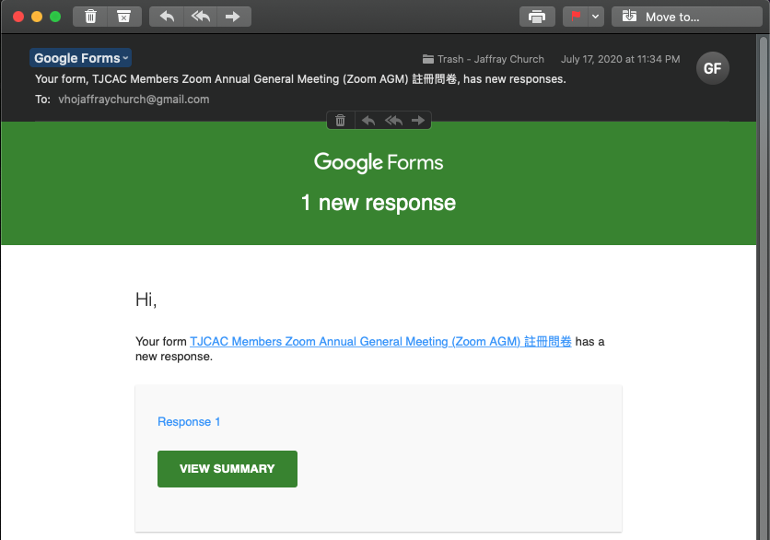

- Under the “Responses” tab and “Individual” tab (see Figure 6.), review the answer to every question to determine if the Registration is a. “Pre-Screen Negative” or b. “Pre-Screen Positive”.
Figure 6. Individual Response
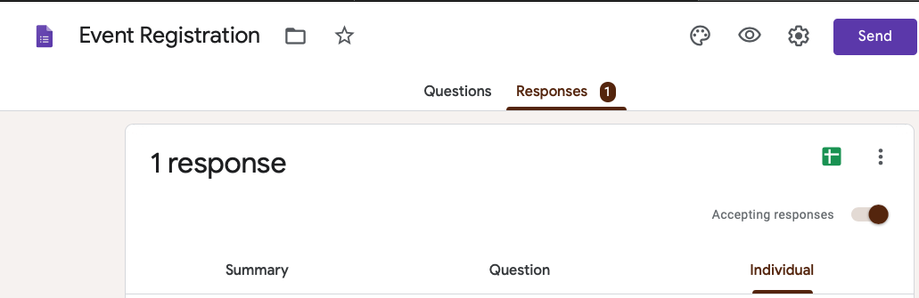
  - If the Registration is “Pre-Screen Negative” assign a Ticket Number to that registration and send an email response to the Registrant.
    - You will identify the Ticket Number to assign by selecting “View Responses in Sheets” and opening a new web page. (see Figure 7.)
Figure 7. View Responses in Sheets
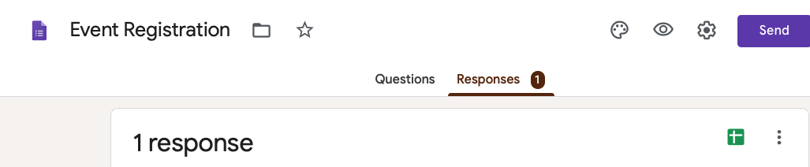

    - In the new Sheets web page, add 3 titles under the next 3 columns “Pre-Screen Neg”, “Ticket Number”, “Pre-Screen Pos” (see Figure 8.)
Figure 8. Add Sheets New Column Titles
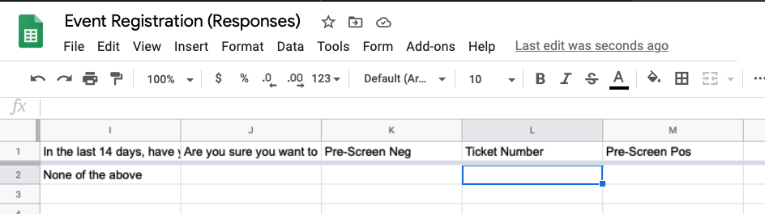
    - In the cell for that “Registration” and “Pre-Screen Neg” enter “1” (see Figure 9.)

Figure 9. Add Marker for Pre-Screen Neg
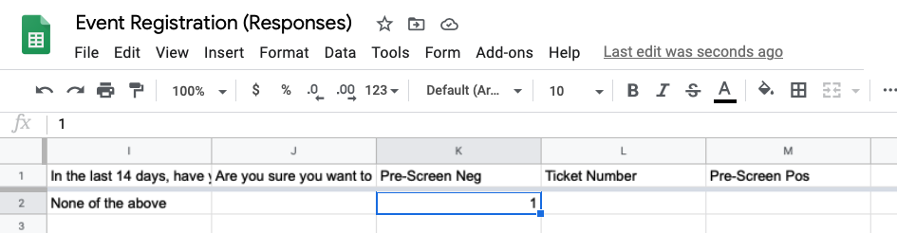
    - In the cell for that “Registration” and “Ticket Number” enter “X” (next ticket number (see Figure 10.)
Figure 10. Add Ticket Number
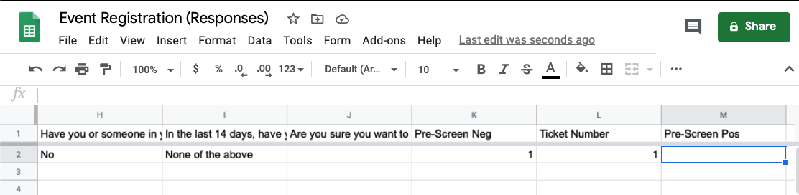

  - If the Registration is “Pre-Screen Positive”, the Ministry Team will have a process to connect with the registration and offer alternative virtual connection options.
    - In the cell for that “Registration” and “Pre-Screen Pos” enter “1”. (see Figure 11.)
Figure 11. Add marker for Pre-Screen Pos
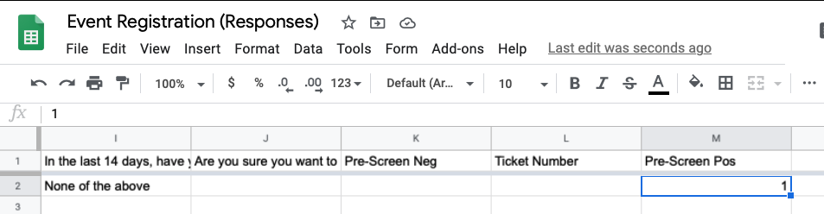

- Before the in person Event, the Secretary will close the on line Event Registration, by selecting the “Reponses” tab, and toggling the “Accepting responses” button (see Figure 12.) and share the Event Registration Sheets with the Ministry Team, including the Head Usher of the Event.
Figure 12. Close the on line Event Registration.
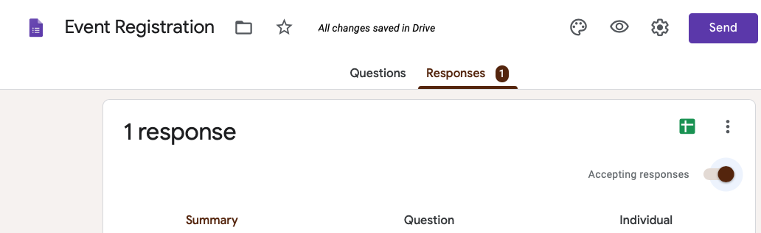
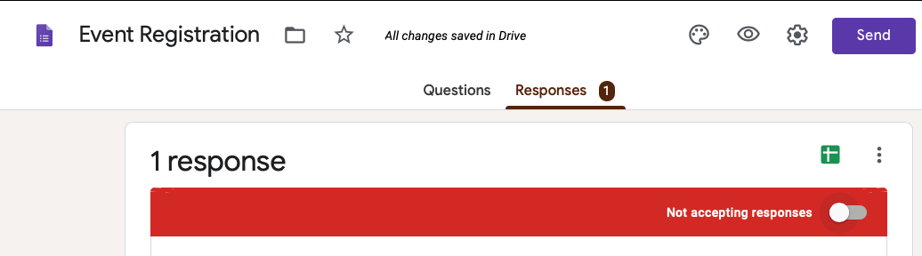

- The Head Usher will have a printed copy of the Event Registration Sheets and cross reference the attendees at the Event.
  - For each attendee at entry, the Ushers will:
    - Ask “What is your Ticket Number?”
      - If they do not have a Ticket Number, proceed to 10.
    - Ask “Have there been any changes to your health status since your Event Registration?”
      - If they have had changes, they should be directed to go home and attend the event virtually.
    - Direct the attendee from the entrance to their seat.

- The Head Usher will have paper copies of the on line Event Registration Form (see Appendix 1.) available for registering any Attendee who shows up without a Ticket Number for the event.
  - If the Event has reached maximum capacity (Sanctuary 120, Fellowship Hall 30), the Attendee will be directed to go home and participate virtually.

- Upon completion of the Event, the Secretary will retrieve all the records of the Attendees from the Head Usher, including any paper registrations completed at the Event.
  - The Secretary will enter all Attendees into the Event Registration Sheets and send a copy to the Secretary of the Board of Elders through church administrative assistant carmen.li.9950@gmail.com to archive the record for the Event.

Appendix 1. Sample Paper Copy of On Line Event Registration
Event registration - English Worship
Event Timing: Sunday, August 2, 2020 9am
Event Address: 9950 Sheppard Ave. E., Toronto, ON M1B 5R6
Contact us at (416) 282-2063 or jaffrayevents@gmail.com

- Name: __________________________________________

- Email address: ____________________________________

- Phone number: ___________________________________

- Are you currently experiencing any of these symptoms?
Fever (feeling hot to the touch, a temperature of 37.8 degrees Celsius or higher)
Chills
Cough that's new or worsening (continuous, more than usual)
Barking cough, making a whistling noise when breathing (croup)
Shortness of breath (out of breath, unable to breathe deeply)
Difficulty swallowing
Sore throat (not related to seasonal allergies or other known causes or conditions)
Runny nose (not related to seasonal allergies or other known causes or conditions)
Stuffy or congested nose (not related to seasonal allergies or other known causes or conditions)
Lost sense of taste or smell
Pink eye (conjunctivitis)
Headache that’s unusual or long lasting
Digestive issues like nausea/vomiting, diarrhea, stomach pain (not related to other known causes or conditions)
Muscle aches that are unusual or long lasting
Extreme tiredness that is unusual (fatigue, lack of energy)
Falling down often
For young children and infants: sluggishness or lack of appetite
New rash that is unexplained (especially on toes)
New inattention or confusion
None of the above

- Are you in any of these at-risk groups?
Getting treatment that compromises (weakens) your immune system
Having a condition that compromises (weakens) your immune system (for example, lupus, rheumatoid arthritis, immunodeficiency disorder)
Having a chronic (long-lasting) health condition (for example, diabetes, emphysema, asthma, heart condition, COPD)
Regularly going to a hospital or health care setting for a treatment (for example, dialysis, surgery, cancer treatment)
Age 70 years or older
None of the above

- Have you travelled outside of Canada in the past 14 days?
No Yes

- Have you or someone in your social circle (including people you live with) had close physical contact with someone who tested positive for COVID-19?
No Yes

Screen Negative – Ticket Number: _____________

Screen Positive – Direct to go home and attend Event virtually.

